Developer Guide

## Software Requirements

1. Java 8
2. Maven
3. Eclipse IDE

## Build Project

1. Extract the shared maven project to any location and go to the folder named – **Log-Parser**
2. Inside the folder there must be a batch file named - **build.bat**
3. Just click and it starts building the war.
4. After successful building of the war, click on the **run.bat** file and it will starts the application on embedded tomcat using Spring Boot.

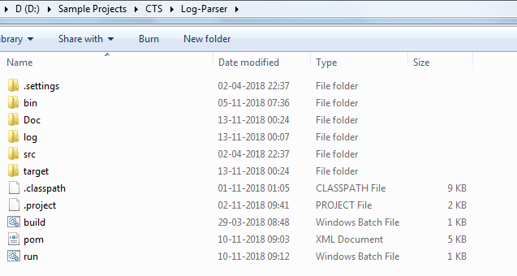

## Deployment Configuration changes at compile time

1. Go to the location – **Log-Parser\src\main\resources**

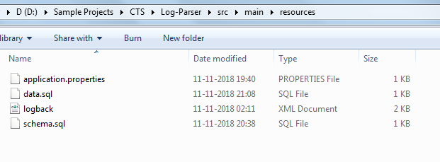

* 1. Change **application.properties**–

DB related configurations

1.2 Change **schema.sql**

Create table for H2 database